**CÉGEP DE LA GASPÉSIE ET DES ÎLES**

**Montreal, Quebec**

C:\Users\1992744\Desktop\resize.jpg

Final Year Project Report on

**Internship - End Of Program**

**Code: 318-ENW-MT**

**Submitted by:**

**Team 4**

**Sukhmanpreeet Kaur & 1993645**

**Parwinder Kaur & 1993770**

**Kulwinder Kaur & 19XXXX**

**Bindu Bindu & 1993480**

**Darshan Joshi & 1995966**

**Bipan Dadra & 19XXX**

**Submission Date**

**DD—MM-2021 Submitted to**

**Department of Mobile Application Development**

**Internship – End of Program**

**(Mobile Application Development)**

Code: 318-ENW-MT

**Submitted by:**

**Team 4**

**Sukhmanpreeet Kaur &19XXXX**

**Parwinder Kaur & 19XXXX**

**Kulwinder Kaur & 19XXXX**

**Bindu Bindu & 19XXX**

**Darshan Joshi & 19XXXX**

**Bipan Dadra & 19XXXX**

**Under the Guidance of**

Prof. Lucas Brantecula

Prof. Soumaya Chaffar

**CÉGEP DE LA GASPÉSIE ET DES ÎLES**

Montreal, Quebe

**ACKNOWLEDGEMENT**

.

Table of Contents

1. Introduction **1**

1.1 General Description 1

1.2 Purpose 1

1.3 Scope 1

2. Specific Requirements **2**

2.1 Functional Requirements 2

3.2 Non-functional Requirements 4

3. Analysis Model **7**

3.1 Use Case Diagram 7

3.2 Use Case Scenarios 7

3.3 Class Diagram 7

3.4 Screen Diagram 7

**4. User Stories** **8**

5. Database Schema **8**

5.2 Queries 8

5.2 Entity Relationship Diagram 8

6. Web Calls **9**

7. Screen Flow Diagram **10**

7.1 Individual Screens 10

8. Test Case Scenarios **11**

**References** **11**

# 1. Introduction

## 1.1 General Description

Quiz Fun application provides different types of quiz tests related to different subjects and topics. This application contains different fields of knowledge like Computers, Mathematics, Learning French, and Science. Many applications are available for the quiz for fun, but our application provides knowledge along with fun. With the help of this application students can not only prepare themselves for different competitions, but they can also gain more and more knowledge even if they would be wrong, they can get right answers afterwards. Students can get their knowledge on smartphones. This is an interesting and easy way to earn knowledge and learn new things.

## 1.2 Purpose

The main purpose of this application is learning -,gaining and improve the knowledge of students. Students can learn a different language with the help of this application.It also provides the quiz about computer hardware,computer software, science , mathematics etc.

## 1.3 Scope

Scope of our application is to check and provide the knowledge to the students. Sometimes, users use quiz application as a pre-test or sometimes as a post-test. So its easy way for students to check their knowledge and increase it in simple and easy way.

# 2. Specific Requirements

## 2.1 Functional Requirements

|  |  |  |  |
| --- | --- | --- | --- |
| **Requirement ID** | **Requirement Statement** | **Must/Should/Could/Would** | **Comments** |
| FR001 | A user must be logged into the application with authenticated username and password. | MUST | The system shall save the username and password within the database. |
| FR002 | A logged in user shall be able to sign out of the application. | MUST | The system shall logout the user of the app. |
| FR003 | A user shall be able to reset the password of the app. | MUST | The system shall update the user password in the database. |
| FR004 | Verification email is sent to the user whenever he/she registers for the first time on some software system. | MUST | The system shall send the verification email for authentication of the user. |
| FR005 | A user must be able to add questions (cards) in the database. | MUST | The system shall add the questions in the database. |
| FR006 | The user must be notified whether or not their input is the correct answer to the question. | MUST | The system shall check the correct answer of the question. |
| FR007 | A user must be provided the amount of total questions they correctly answered out of total questions given in the form of percentage | MUST | The system shall show the result. |
| FR008 | A user must be able to add the rating. | MUST | The system shall add the rating in the database. |
| FR009 | A user can be able to provide the questions they correctly and incorrectly answered. | MUST | The system shall show the right and wrong answers. |
| FR010 | A user must be able to manage the profile accordingly. | MUST | The system shall update the user profile in the database. |
| FR011 | A user must use a correct email to sign in the account. | MUST | The system shall login the user with correct email. |

## 3.2 Non-functional Requirements

|  |  |  |
| --- | --- | --- |
| Requirement ID | Requirement Statement | Type |
| NFR001 | A user shall not be able to add more than one account in the app. | Security |
| NFR002 | The user can edit the profile at any time and it must be updated within 5 seconds. | Performance |
| NFR003 | The application should be available to users to use at any time. | Availability |
| NFR004 | The username and password should be authenticated within 5 seconds by the system. | Performance |
| NFR005 | Every unsuccessful attempt by a user to access an item of data shall be recorded on an audit trail .Continuous 3 unsuccessful attempts leads to blockage timeout of 3 minutes. | Security |
| NFR006 | Maximum 1000 students can use the app at the same time. | Scalability |
| NFR008 | A user must be able to complete any operation without assistance 90% of the time. | Usability |
| NFR009 | The database may crash at any time due to virus and any other operating system, so the database backup must be taken by the user at any time. | Safety |
| NFR010 | The user must have a function to pop-up error messages in case of component failure. | Availability |

# 3. Analysis Model

## 3.1 Use Case Diagram

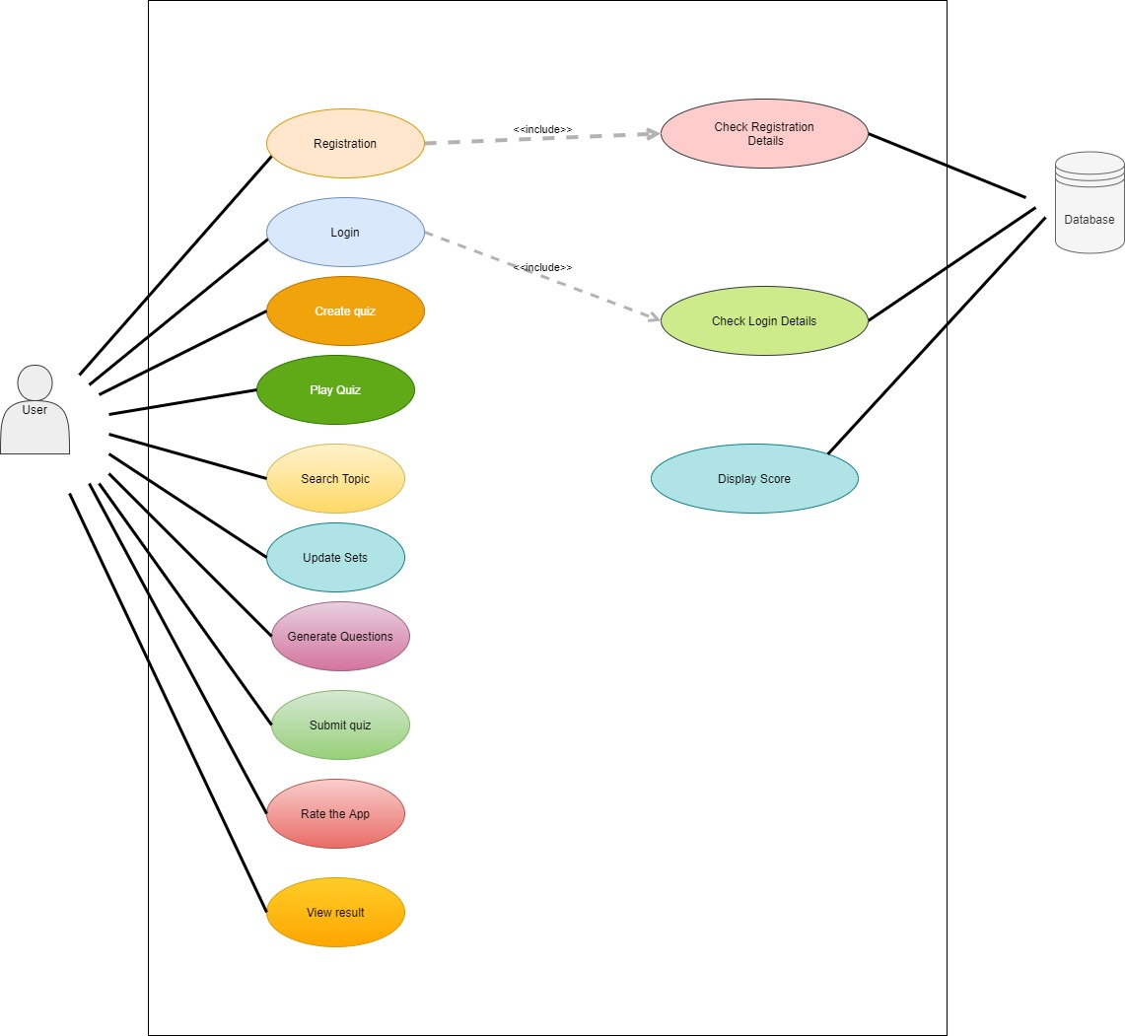

## 3.2 Use Case Scenarios

## 3.3 Class Diagram

## 3.4 Screen Diagram

# 4. User Stories

# 5. Database Schema

## 5.2 Queries

## 5.2 Entity Relationship Diagram

# 6. Web Calls

# 7. Screen Flow Diagram

## 7.1 Individual Screens

**Conclusion & Recommendations**

# 8. Test Case Scenarios

# 

# 

# References